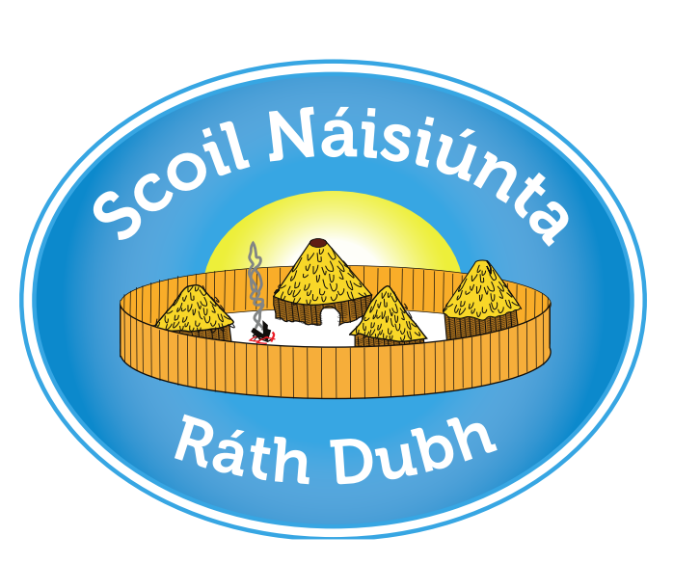

Rathduff NS
ANNUAL ADMISSION NOTICE
in respect of admissions to the 2022/2023 school year

Admission Policy and Application Form
A copy of the school’s Admission Policy and the Application Form for Admission for the School Year 2022/23 is available as follows: –
To download at: www.rathduffnationalschool.com
On request: By emailing rathdubhns@eircom.net or writing to:
Rathduff NS,
Grenagh,
Co. Cork
T23XO29

PART 1 - Admissions to the 2022/2023 school year

Application and Decision Dates for admission to 2021/2022
The following are the dates applicable for admission to Junior Infants

The school will commence accepting applications for admission on | 04/10/2021
The school shall cease accepting applications for admission on | 05/11/2021
The date by which applicants will be notified of the decision on their application is | 26/11/2021
The period within which applicants must confirm acceptance of an offer of admission is | 10/12/2021
*Failure to accept an offer within the prescribed period above may result in the offer being withdrawn

Note: the school will consider and issue decisions on late applications in accordance with the school’s admission policy.

Special Class Application and Decision Dates for admission to 2022/2023
The following are the dates applicable for admission to the school’s Special Classes which caters for children with Autism -
The school will commence accepting applications for admission to the special class on | 04/10/2021
The school shall cease accepting applications for admission to the special class on | 04/02/2022
The date by which applicants will be notified of the decision on their application for admission to the special class is | 28/02/2022
The period within which applicants must confirm acceptance of an offer of admission is | 14/03/2022
*Failure to accept an offer within the prescribed period above may result in the offer being withdrawn

Number of places being made available in 2022/2023

The number of places being made available in junior infants is | 30
The number of places being made available in the special classes catering for children with Autism is  (Early Intervention 5/ASD Classes 3) | 8

PART 2 - Admissions to the 2021/2022 school year
Information regarding the admission process for the Intake Group for Special Classes for the 2021 school year

In respect of the 2021/2022 school year
In respect of 2021/2022 school year, the total number of applications for admission received by the school was____18___________
Breakdown of places allocated for the 2021/22 school year:
Number of places available: | 2
Number of applications received: | 18
Number of Offers made and accepted under each criteria: | Criterion 1: Pupils transferring from our Mainstream Classes-0  Criterion 2: Brothers and sisters (including step-siblings, or foster children resident at the same address) of children already enrolled- 0  Criterion 3: Pupils from our Early Intervention Class- 0  Criterion 4: Children Living within the parish-2  Criterion 5: Children whose home address is closest to the school (as measured by google maps) if the child is normally resident outside the parish/agreed catchment area -0
Total number of offers made | 2
Number of names placed on waiting list for the school year concerned. | 16

