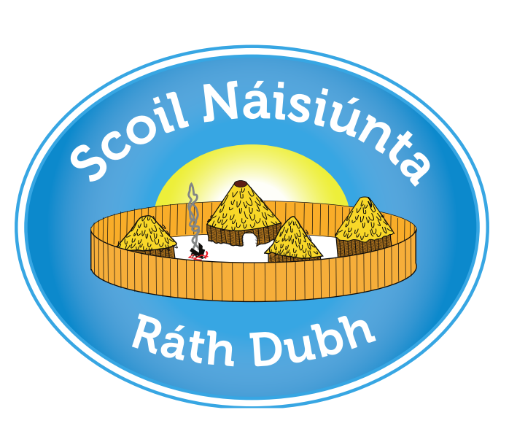
Roll Number: 08393P
RATHDUFF NS
APPLICATION FOR ADMISSION FORM 2022-2023

Please specify which class you wish to apply for: e.g. Junior Infants /1st Class/3rd Class/5th Class /EI /ASD etc: ___________________
Places will be offered to applicants based SOLELY on the information given on this form.
Applications for pupils applying to transfer from another school into classes other than Junior Infants may be subject to certain conditions as per the school’s Admission Policy.
If you have any questions about how to fill out this form, please contact the school for assistance. Please complete the form in BLOCK CAPITALS.

Name of Child: ________________________________ Date of Birth: ____________
Home Address: _______________________________________________________________________
Eircode: ________________________
Please attach copies of two proofs of address valid within three months of the date of this application e.g. utility bill, bank statement (block out transactions).
Details of Parent/Guardian 1. | Details of Parent/Guardian 2.
Name: | Name:
Mobile No: | Mobile No:
Work No: | Work No:
Email: | Email:

Names of brothers/sisters who are attending or have attended our school:
1._________________________________ 2._____________________________
3._________________________________ 4._____________________________

Is your child currently attending our Early Intervention Class:
Yes No

Any other information relevant to this Application for Admission: _____________________________________________________________________
_____________________________________________________________________
_____________________________________________________________________
_____________________________________________________________________
_____________________________________________________________________

Signature of Parent/Guardian 1: __________________________ Date: __________
Signature of Parent/Guardian 2: __________________________ Date: __________

This form must be returned to: School Office, Rathduff NS, Rathduff, Grenagh, Co. Cork T23XO29 by 3:00pm on Friday 5th November 2021.
Any application received after this date will be treated as a late application in accordance with our Admissions Policy.
Please note: A further form requiring more detailed information will be forwarded to you should you be offered a place in the school and accept that place in writing.

