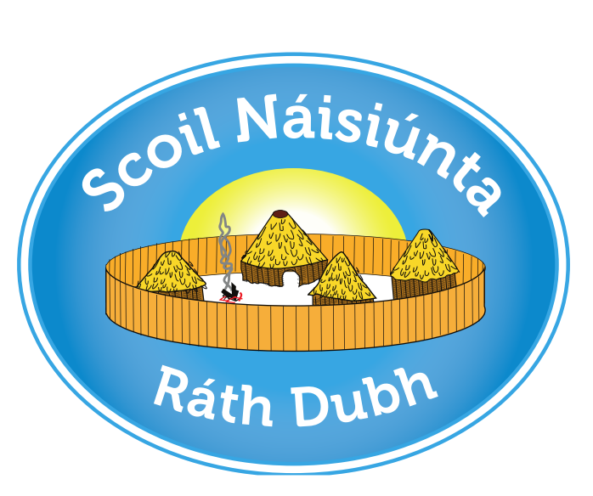

Rathduff NS
ANNUAL ADMISSION NOTICE
in respect of admissions to the 2027/2028 school year

Admission Policy and Application Form
A copy of the school’s Admission Policy and the Application Form for Admission for the School Year 2027/28 is available as follows: –
To download at: www.rathduffns.com
On request: By emailing rathduffnationalschool@gmail.com or writing to:
Rathduff NS,
Grenagh,
Co. Cork
T23XO29

PART 1 - Admissions to the 2027/2028 school year

Application and Decision Dates for admission to 2027/2028
The following are the dates applicable for admission to Junior Infants

The school will commence accepting applications for admission on | 01/10/2026
The school shall cease accepting applications for admission on | 31/10/2026
The date by which applicants will be notified of the decision on their application is | 27/11/2026
The period within which applicants must confirm acceptance of an offer of admission is | 11/12/2026
*Failure to accept an offer within the prescribed period above may result in the offer being withdrawn

Note: the school will consider and issue decisions on late applications in accordance with the school’s admission policy.

Special Class Application and Decision Dates for admission to 2027/2028
The following are the dates applicable for admission to the school’s Special Classes which caters for children with Autism -
The school will commence accepting applications for admission to the special class on | 01/10/2026
The school shall cease accepting applications for admission to the special class on | 31/10/2026
The date by which applicants will be notified of the decision on their application for admission to the special class is | 27/11/2026
The period within which applicants must confirm acceptance of an offer of admission is | 11/12/2026
*Failure to accept an offer within the prescribed period above may result in the offer being withdrawn

Number of places being made available in 2027/2028

The number of places being made available in junior infants is | 30
The number of places being made available in the special classes catering for children with Autism is | 3

PART 2 - Admissions to the 2026/2027 school year
Information regarding the admission process for the Intake Group for Special Classes for the 2026 school year

In respect of the 2026/2027 school year
In respect of 2026/2027 school year, the total number of applications for admission received by the school was____13___________
Breakdown of places allocated for the 2026/27 school year:
Number of places available: | 7
Number of applications received: | 13
Number of Offers made and accepted under each criteria: | Criterion 1: Pupils transferring from our Mainstream Classes-1  Criterion 2: Brothers and sisters (including step-siblings, or foster children resident at the same address) of children already enrolled- 1  Criterion 3: Pupils from our Early Intervention Class- 1  Criterion 4: Children Living within the parish-3  Criterion 5: Children whose home address is closest to the school (as measured by google maps) if the child is normally resident outside the parish/agreed catchment area -1
Total number of offers made | 7
Number of names placed on waiting list for the school year concerned. | 6

